**SUPPLY CHAIN**

|  |
| --- |
| How we work – Supply chain – **Supplier registration form**    All to be starred except Landline and Organisation website.  Starring means: E.g. Legal Name of Organisation*  Please replace No file chosen with Upload file here   Files must be less than xx MB. Allowed file types are: PDF, Doc, Docx, PPT, JPG, PNG (VIVEK PLEASE CHECK AND REVERT) |
| How we work – Supply chain – Supplier registration form – **Banking information**    All to be starred |
| How we work – Supply chain – Supplier registration form – **Products and Services**    All to be starred |
| How we work – Supply chain – Supplier registration form – **QHSE**    Please replace the word QHSE (Form section title) with the word **certification** and add a star * at the end of the check box statement |

**Non-Emergency Patient Transport Form**

|  |
| --- |
| Services – Non-Emergency Patient Transport (PTS) - **Non-Emergency Patient Transport Form**    All to be starred + Please replace No file chosen with Upload file here |
| Services – Non-Emergency Patient Transport (PTS) - Non-Emergency Patient Transport Form – Transport details **– Hospital Transfer**    All to be starred + **Date format to change to Day/Month/Year** |
| Services – Non-Emergency Patient Transport (PTS) - Non-Emergency Patient Transport Form – Transport details – **Medical Appointment Transfer**    All to be starred except GPS Coordinates + **Date format to change to Day/Month/Year** |
| Services – Non-Emergency Patient Transport (PTS) - Non-Emergency Patient Transport Form – **Primary contact**    All to be starred |
| Services – Non-Emergency Patient Transport (PTS) - Non-Emergency Patient Transport Form – **Additional Information**    Add a star * at the end of the check box statement. |

**Event Emergency Medical Coverage**

|  |
| --- |
| Services – Event Emergency Medical Coverage – Event Emergency Medical Coverage Form – **Event Details**    All to be starred - Please fix the time issue, it doesn’t show the label name as a default and make sure that the label name appears when if you delete the time you entered and clicked out of it.  **Date format to change to Day/Month/Year** |
| Services – Event Emergency Medical Coverage – Event Emergency Medical Coverage Form – **Primary Contact**  All to be starred |
| Services – Event Emergency Medical Coverage – Event Emergency Medical Coverage Form – **Additional Information**    Please replace No file chosen with Upload file here. |

**Contact US Form**

|  |
| --- |
| **Please star the following:**  Type of Enquiry*  Contact Number* Email* Company Name* Country* City (not mandatory)   Message* |

**Feedback Forms**

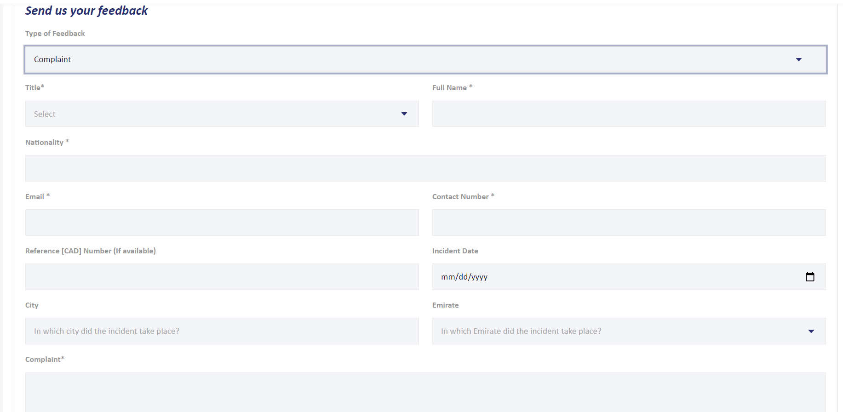

|  |  |  |  |
| --- | --- | --- | --- |
| **Complaint** | **Compliment** | **Suggestion** | Other |
| Keep the ones that are already starred and add/star:  Type of feedback*  City*  Emirate*  Date format to change to Day/Month/Year | Keep the ones that are already starred and add/star:  Type of feedback*  City*  Emirate*  Date format to change to Day/Month/Year | Keep the ones that are already starred and add/star:  Type of feedback*  **(Note: Emirate of Residence is not mandatory)** | Keep the ones that are already starred and add/star:  Type of feedback*  **(Note: Emirate of Residence is not mandatory)** |

NOTE:

* ALL Date format to change to Day/Month/Year (as requested before)
* File Attachments (What does best practice say? We mention the size of documents/ and type? Or it appears are part of the error message when people exceed the limit?

e.g. Files must be less than xx MB. Allowed file types are: PDF, Doc, Docx, PPT, JPG, PNG

(VIVEK PLEASE CHECK AND REVERT)